**Installing Mongo db**

1. Download mongo db from [MongoDB Community Download | MongoDB](https://www.mongodb.com/try/download/community)

(Community Version)

1. Go to the path – c:\program files\mongodb\server\5.0\bin

In the cmd prompt type -- mongod.exe --dbpath F:\python-mongo

(mongo server will be running in port no-27017.url -”mongodb://localhost:27017/”)

1. Download compass from [MongoDB Community Download | MongoDB](https://www.mongodb.com/try/download/community)

Compass is a GUI for analyzing mongo db.

1. Create a database, collection(Table)
2. Install pymongo module.
   1. Pm –m pip install pymongo
3. In the python file
   1. Import pymongo
   2. url = ”mongodb://localhost:27017/”
   3. mongoServer=pymongo.MongoClient(url)
   4. db=momgoServer[“school”]
   5. collection=db[“students”]
   6. document={“name”:”s1”,”rno”:”1”,”loc”:”Hyd”}
   7. res=collection.insert_one(document)
   8. print(res)

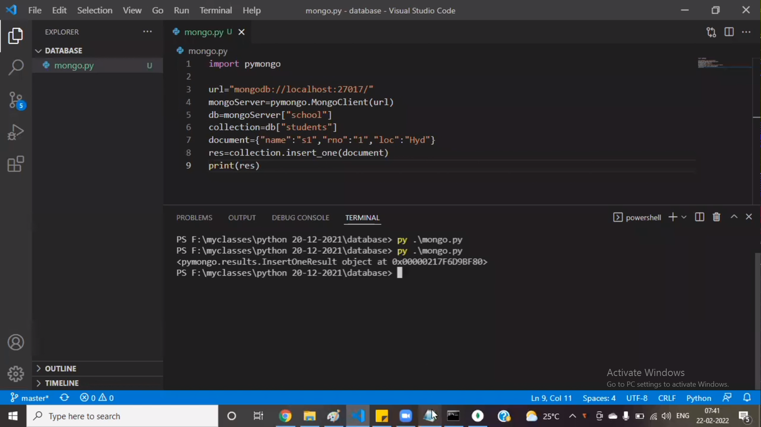

Check in compass if the data is inserted.

2 Retrieve the data

1. Import pymongo
2. url = ”mongodb://localhost:27017/”
3. mongoServer=pymongo.MongoClient(url)
4. db= mongoServer [“school”]
5. collection=db[“students”]
6. documents = collection.find()# want to get all the records
7. for doc in documents:
   1. print(doc)

documents = collection.find({“name”:”s1”})# want to query for particular row